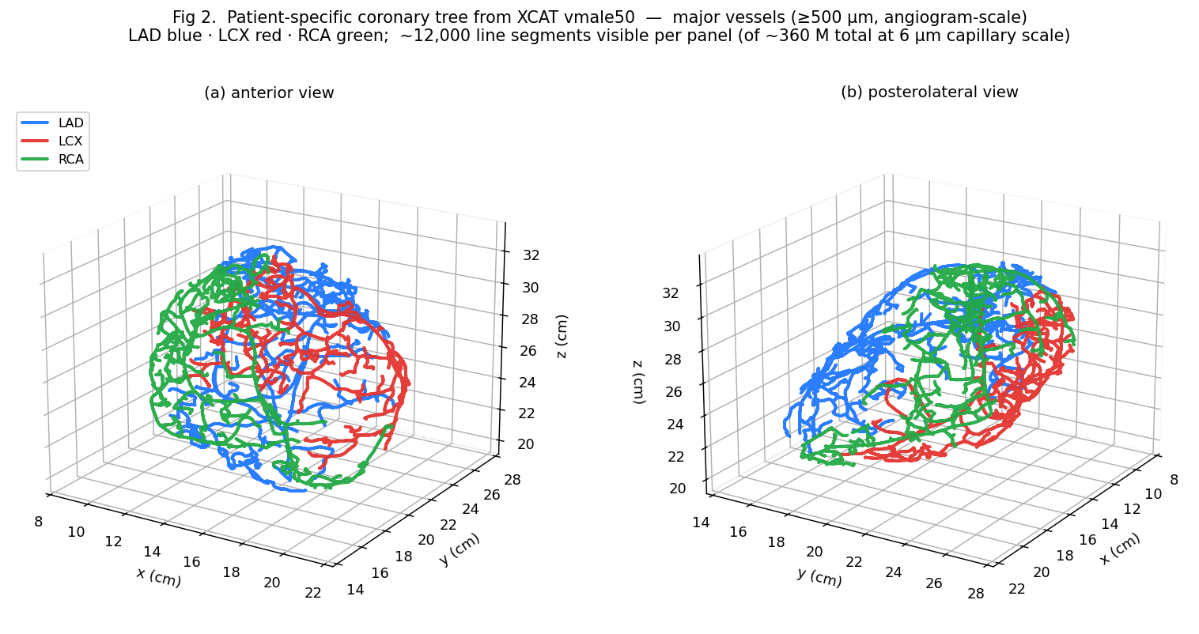
Figure 2. Patient-specific coronary tree generated from the XCAT vmale50 digital phantom, shown at angiogram-scale (segments ≥500 μm). Two viewpoints — (a) anterior, (b) posterolateral — illustrate the spatial extent and branching pattern of the simulated trees. LAD (blue, 4779 visible segments), LCX (red, 3347), RCA (green, 4130). The tree was grown by competitive constrained constructive optimization (CCO) from XCAT NRB centerlines, expanded to 200 μm using GPU-accelerated weighted-Voronoi territory assignment with Dodge 1992 anatomical proximal-diameter priors (LAD 3.7 mm, LCX 3.4 mm, RCA 3.9 mm), and recursively bifurcated to 6 μm capillary terminals. The full simulation contains ~360 million segments at capillary resolution; the ≥500 μm subset shown here is the level visible at typical clinical-angiography reconstruction.
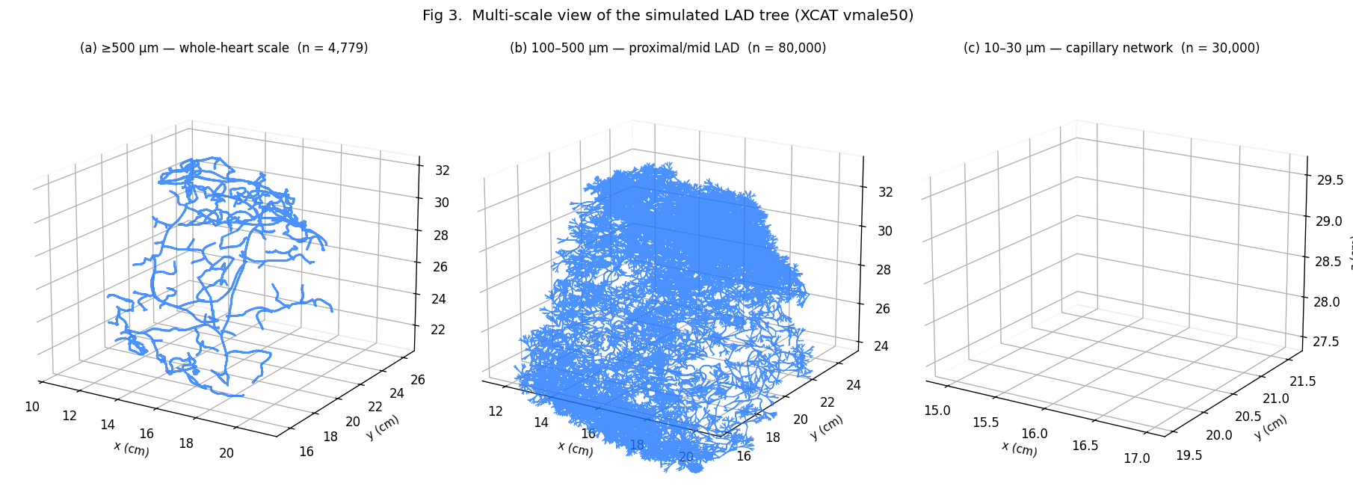
Figure 3. Multi-scale view of the simulated LAD tree. (a) Whole-heart scale — segments with diameter ≥500 μm (n = 4779), corresponding to vessels visible at routine clinical CT-angiography. (b) Intermediate scale — segments 100–500 μm (n = 80,000), typical of small intramural arteries; the panel is zoomed to a 5 cm cube centered on the LAD median. (c) Capillary scale — segments 10–30 μm (n = 30,000 of 14.7 million total in this band), zoomed to a 1.2 cm cube. The pipeline produces continuously-resolved vasculature from millimeter-scale ostia down to capillary diameter (6 μm subdivision target) using physics-grounded Murray-law diameter propagation and domain-clipped recursive bifurcation. The total LAD tree contains 121.5 million segments after subdivision.

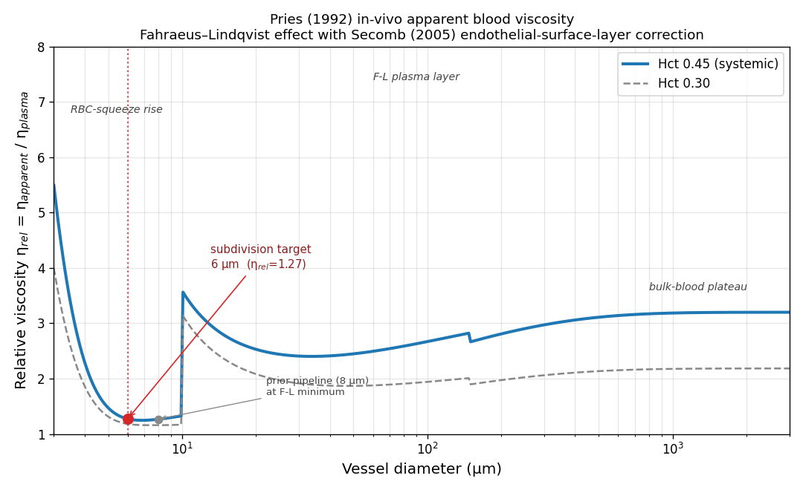
Figure 4. Pries (1992) in-vivo apparent blood viscosity as a function of vessel diameter, with Pries-Secomb (2005) endothelial-surface-layer (ESL) correction. Solid blue: systemic discharge hematocrit (0.45). Dashed grey: capillary-bed hematocrit (0.30, Fahraeus effect). Three regimes are visible: (i) the "RBC-squeeze rise" below ~5 μm where red blood cells must deform to traverse capillary lumen, (ii) the Fahraeus-Lindqvist plasma-layer minimum near 8 μm, and (iii) the bulk-blood plateau above ~300 μm. The pipeline targets terminal subdivision at 6 μm (red marker) — on the leading edge of the RBC-squeeze rise — providing physically meaningful capillary resistance. The earlier 8 μm target (grey marker) sat exactly at the F-L minimum and underestimated downstream resistance. The discontinuity at 10 μm is the documented ESL activation threshold in the Pries-Secomb 2005 model. The LAD ostium operates in the bulk-blood regime (3.7 mm, green square).
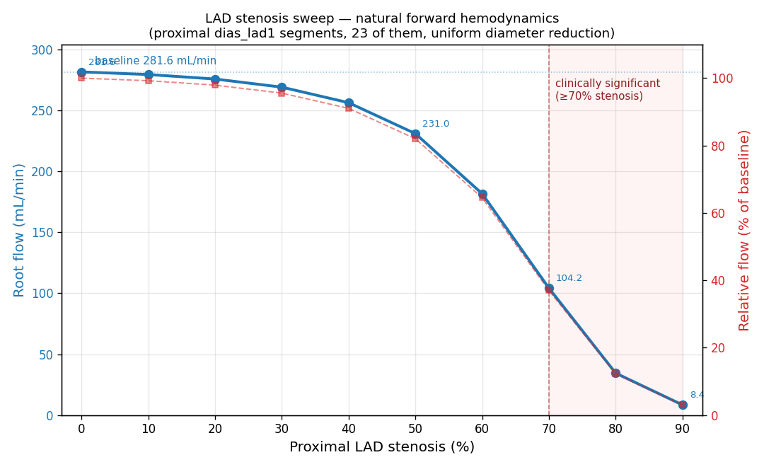
Figure 5. LAD proximal stenosis sweep. The 23 segments labelled "dias_lad1" (≈12 mm of proximal LAD adjacent to the aortic ostium) were uniformly narrowed by 0%, 10%, …, 90%; for each level the entire 154-million-segment tree was re-solved under fixed 100 → 15 mmHg boundary conditions. Blue solid line (left axis): absolute root flow in mL/min. Red dashed line (right axis): flow as a percentage of the 0%-stenosis baseline (281.6 mL/min). The simulated curve reproduces the classic Gould fractional-flow-reserve relationship: <50 % stenosis preserves >82 % of baseline flow (autoregulation-equivalent plateau in Poiseuille), the curve transitions sharply between 60–80 %, and 70 % stenosis — the clinically significant threshold (red shaded region) — reduces flow to 37 % of baseline. At 90 % stenosis, flow collapses to 3 % of baseline (8.4 mL/min). The result emerges purely from natural Poiseuille + Pries physics with no calibration to clinical reference values.
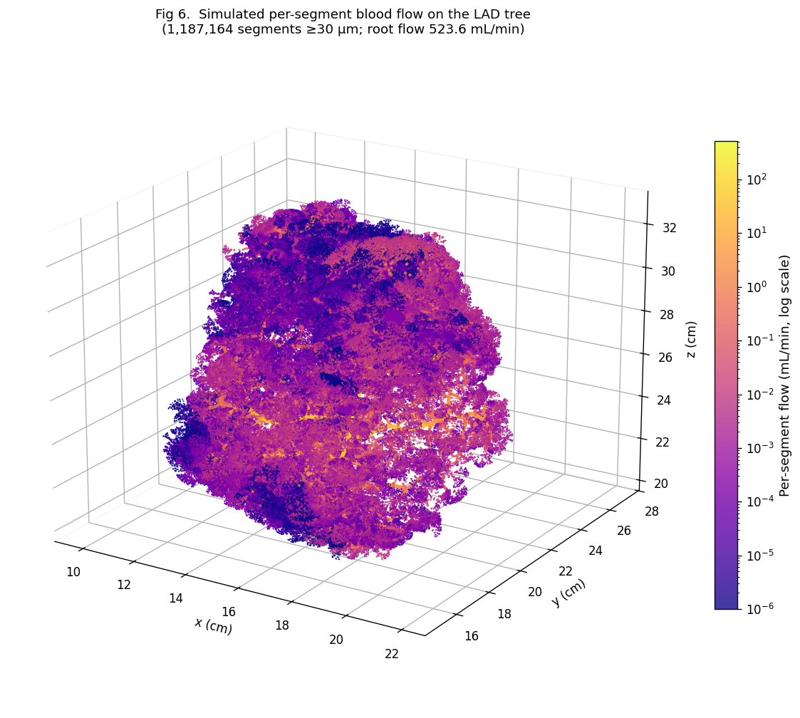
Figure 6. Per-segment blood-flow heat-map on the simulated LAD tree, with each plotted segment (n = 1.19 million ≥30 μm segments shown out of 121.5 million total) colored by its computed flow in mL/min on a log scale. The colormap spans nine decades — from <10⁻⁵ mL/min in distal capillaries to 5.2×10² mL/min at the root — driven entirely by Hagen-Poiseuille resistance with Pries (1992) non-Newtonian viscosity (no calibration). Marker size scales with vessel diameter. Yellow / bright regions highlight the proximal LAD trunk; the gradient toward purple shows the natural Murray-law cubic flow split at each bifurcation as flow distributes from the ostium to capillary territory. The total simulation includes ~360 million segments across LAD/LCX/RCA.

